**TEMPERATURE MONITORING SYSTEM**

**PROJECT REPORT**

**BACHELOR OF TECHNOLOGY**

ELECTRONICS AND COMMUNICATION ENGINEERING

**SUBMITTED BY**

**ISHA GUPTA (15ECU022)**

**MONALI KAR (15ECU029)**



**THE NORTHCAP UNIVERSITYHUDA SECTOR 23A, GURUGRAM, 122017, INDIA**

**CONTENT**

* Acknowledgement
* Introduction
* Construction
  + Components used
* Protocols
* Working
  + Circuit diagram
* Application
* Reference

**ACKNOWLEGEMENT**

We have taken efforts in this project. However, it would not have been possible without the kind support and help of many individuals and institute. We would like to extend my sincere thanks to all of them.

We are highly indebted to **MS. Aakriti Khanna** for their guidance and constant supervision as well as for providing necessary information regarding the project & also for their support in completing the project.

We would like to express my gratitude towards my parents for their kind co-operation and encouragement which help me in completion of this project.

Our thanks and appreciations also go to my colleague in developing the project and people who have willingly helped me out with their abilities.

**INTRODUCTION**

Temperature is the most often-measured environmental quantity. This might be expected since most physical, electronic, chemical, mechanical, and biological systems are affected by temperature. Certain chemical reactions, biological processes, and even electronic circuits perform best within limited temperature ranges. Temperature is one of the most commonly measured variables and it is therefore not surprising that there are many ways of sensing it. There are a wide variety of temperature sensors on the market today but we are using LM35 Temperature sensor. In recent advanced era the temperature measurement and its control has become an integral part of any control system operating in a temperature sensitive environment e. g.

* The temperature of food items can be controlled to minimize the bacterial growth without affecting its nutrition value.
* For boilers, temperature is important for water and air preheat, fuel oil viscosity, and steam superheat control.
* The temperature control in cold stores reduces the contamination and degradation rate in pharmaceutical, biochemical, beverage and food industries.
* The temperature control in plant growth chambers is important for studying the effect of hybridization, genetic engineering and plant growth regulators.

**CONSTRUCTION**

**Components used:- Software used:-**

* LM35 Temperature Sensor Thingspeak
* ATMEGA 16 microcontroller
* GSM module

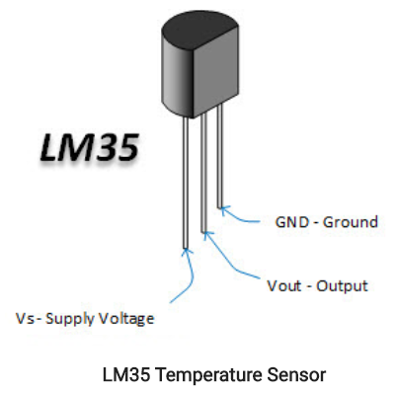LM35 Temperature Sensor

The LM35 temperature sensor is used to detect precise centigrade temperature. The operating voltage range of this LM35 ranges from-55˚ to +150˚C and it has low-self heating. This is operated under 4 to 30 volts. Temperature sensor circuit has terminals such as two inputs like non-inverting (+) and inverting (-) and only one output pin.

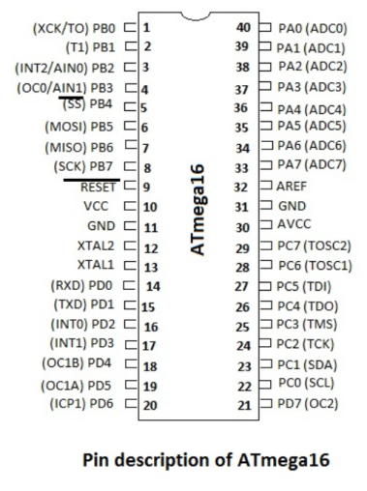ATMEGA 16 Microcontroller

ATmega16 is an 8-bit high performance microcontroller. It consumes less power. They have features such as internal PWM channels, 10-bit A/D converters, UART/USART and much more, which makes them useful for a large number of applications and external hardware is reduced as these are built-in.

GSM Module

 It stands for global system for mobile communication (GSM), Global System for Mobile communication (GSM) is an architecture used for mobile communication. It communicates serially with the devices like a microcontroller, PC using AT commands.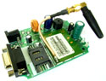 We are using sim with the development of GSM network, one can easily connect the sensor with GSM network, so that you don’t need to be present near the sensor in order to view the temperature. You can just pick up your cell phone and send a request to your sensor by a text message and in no time you will receive the temperature of the remote place. The advantage is that you don’t need any kind of "special" device at the receiver end. You can use any cell phone to view the remote temperature. This reduces cost as you already have a cell phone.

Other benefit is that the range is not limited. You can be at any place in the world (with mobile coverage of course!), to request temperature data from your room.

Thingspeak

ThingSpeak is an open source Internet of Things (IoT) application and API to store and retrieve data from things using the HTTP protocol over the Internet or via a Local Area Network. It enables the creation of sensor logging applications, location tracking applications, and a social network of things with status updates.

**PROTOCOLS**

# UART(Universal Asynchronous Receiver / Transmitter)

It converts data from serial to parallel and vice-versa. The SIM900 GSM modem is interfaced with the microcontroller using a serial protocol UART. The serial port of the GSM modem uses the same UART protocol to enable communication with the microcontroller. A UART's main purpose is to transmit and receive serial data. UART protocol uses the baud rate to tackle the issue of Asynchronous communication.

# GPRS

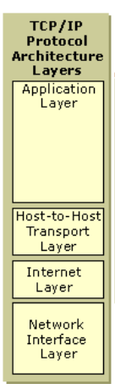GPRS is also known as GSM-IP that is a Global-System Mobile Communications Internet Protocol as it keeps the users of this system online, allows to make voice calls, and access internet on-the-go. It helps to communicate with GSM phone. The GPRS network is designed for packet data transport and especially for Internet connections.

# TCP/IP

Additional protocols may be needed to provide connection over the network, so we use TCP/IP connection i.e. Transmission Control Protocol/Internet Protocol, the communications suite used to transmit data on the internet. The entire internet protocol suite -- a set of rules and procedures -- is commonly referred to as TCP/IP. It transmits a single message, and its connection remains in place until all the packets in a message have been received and reassembled at the destination. TCP/IP functionality is divided into four [layers](https://searchsoftwarequality.techtarget.com/definition/layer), each of which include specific protocols.

The *Network Interface layer* (also called the Network Access layer) is responsible for placing TCP/IP packets on the network medium and receiving TCP/IP packets off the network medium.

The *Internet layer* is responsible for addressing, packaging, and routing functions.

The core protocols of the *Transport layer* are Transmission Control Protocol (TCP) and the User Datagram Protocol (UDP).

TCP provides a one-to-one, connection-oriented, reliable communications service. TCP is responsible for the establishment of a TCP connection, the sequencing and acknowledgment of packets sent, and the recovery of packets lost during transmission.

UDP provides a one-to-one or one-to-many, connectionless, unreliable communications service. UDP is used when the amount of data to be transferred is small (such as the data that would fit into a single packet), when the overhead of establishing a TCP connection is not desired or when the applications or upper layer protocols provide reliable delivery.

The *Application layer* provides applications the ability to access the services of the other layers , which is accountable for AT commands.

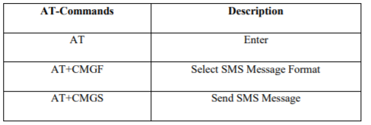

# ADC

Most real world data is analog. Whether it be temperature, pressure, voltage, etc, their variation is always analog in nature. For efficient and ease of signal processing, this analog signal is converted into a digital signal using an Analog to Digital Converter (ADC). The AVR features inbuilt ADC in almost all its MCU. In ATMEGA16/32, PORTA contains the ADC pins. 8 channel implies that there are 8 ADC pins are multiplexed together. You can easily see that these pins are located across PORTA (PA0…PA7).

Apart from this, the other things that we need to know about the AVR ADC are:

* ADC Registers – ADMUX, ADCSRA

## ADMUX – ADC Multiplexer Selection Register **ADMUX** : For selecting the reference voltage and the input channel.

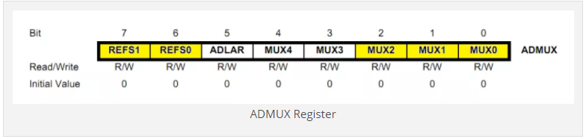

## ADCSRA – ADC Control and Status Register A As the name says it has the status of ADC and is also use for controlling it.

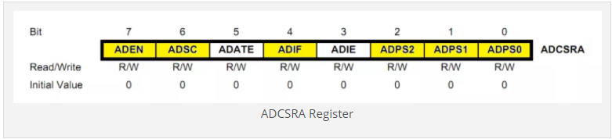

We have to configure the ADC by setting up ADMUX and ADCSRA registers

**WORKING**

I have just combined coding and circuit diagram of those two articles. Circuit Diagram of wireless temperature sensor using pic microcontroller. In above circuit diagram temperature sensor can be located at remote location and you can connect more than one sensor like light sensor, motion sensor ,pressure sensor according to requirement of your project. Lcd is use optional.  Gsm module is used to send sms to any mobile number. You can also use other wire less communication source like Bluetooth if distance is not more than 5 meter.This project have many applications in remote monitoring systems.you can change it with ease according to your specifications.

**AP PLICATION**